Decimal Data Types
# Source: AI Source: Provided by: [Data Path: Persons Table -> ID Column: 1, Name_En Column: Motasem Essam] -> From: [Chatgpt (GPT‑5 Mini)] on [12/10/2025]
decimal is a data type designed to store decimal numbers with very high precision, especially for financial and monetary calculations.
Unlike float and double, which store numbers in binary floating-point, decimal stores numbers in a base-10 format, making it more accurate for decimal values.

Key Characteristics
# Source: AI Source: Provided by: [Data Path: Persons Table -> ID Column: 1, Name_En Column: Motasem Essam] -> From: [Chatgpt (GPT‑5 Mini)] on [12/10/2025]
- Stores numbers with decimal points
- Very high precision
- Ideal for financial calculations
- Avoids rounding errors common with float and double
- Typically uses 16 bytes (128 bits) in many languages

Example Values
# Source: AI Source: Provided by: [Data Path: Persons Table -> ID Column: 1, Name_En Column: Motasem Essam] -> From: [Chatgpt (GPT‑5 Mini)] on [12/10/2025]
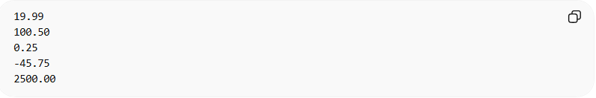
19.99
100.50
0.25
-45.75
2500.00

Example in Programming

C#
# Source: AI Source: Provided by: [Data Path: Persons Table -> ID Column: 1, Name_En Column: Motasem Essam] -> From: [Chatgpt (GPT‑5 Mini)] on [12/10/2025]
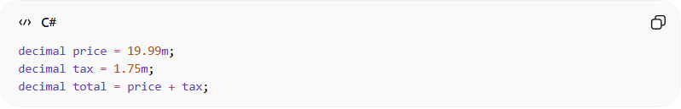
decimal price = 19.99m;
decimal tax = 1.75m;
decimal total = price + tax;

Java (using BigDecimal for precision)
# Source: AI Source: Provided by: [Data Path: Persons Table -> ID Column: 1, Name_En Column: Motasem Essam] -> From: [Chatgpt (GPT‑5 Mini)] on [12/10/2025]
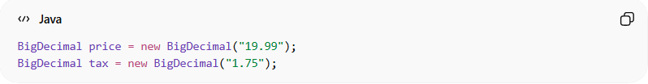
BigDecimal price = new BigDecimal("19.99");
BigDecimal tax = new BigDecimal("1.75");

Precision and Size
# Source: AI Source: Provided by: [Data Path: Persons Table -> ID Column: 1, Name_En Column: Motasem Essam] -> From: [Chatgpt (GPT‑5 Mini)] on [12/10/2025]
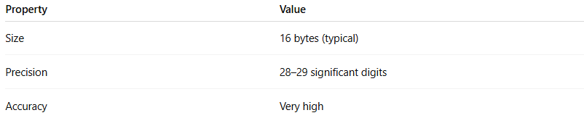
Property | Value
Size | 16 bytes (typical)
Precision | 28–29 significant digits
Accuracy | Very high

Example Calculation
# Source: AI Source: Provided by: [Data Path: Persons Table -> ID Column: 1, Name_En Column: Motasem Essam] -> From: [Chatgpt (GPT‑5 Mini)] on [12/10/2025]
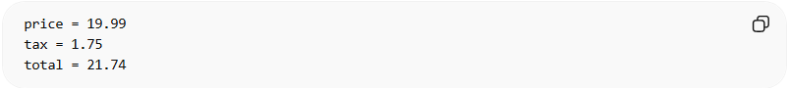
price = 19.99
tax = 1.75
total = 21.74
Using decimal ensures the result is exact, which is important in banking and accounting systems.

When to Use decimal
# Source: AI Source: Provided by: [Data Path: Persons Table -> ID Column: 1, Name_En Column: Motasem Essam] -> From: [Chatgpt (GPT‑5 Mini)] on [12/10/2025]
Use decimal when working with:
- Money and currency
- Financial systems
- Accounting software
- Precise decimal values
Example:
- Bank balances
- Product prices
- Tax calculations

Float vs Double vs Decimal
# Source: AI Source: Provided by: [Data Path: Persons Table -> ID Column: 1, Name_En Column: Motasem Essam] -> From: [Chatgpt (GPT‑5 Mini)] on [12/10/2025]
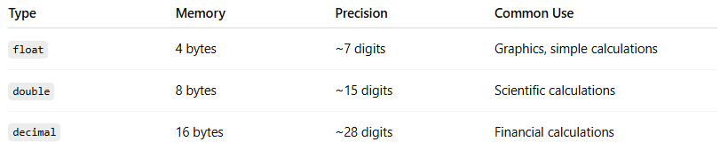
Type | Memory | Precision | Common Use
float | 4 bytes | ~7 digits | Graphics, simple calculations
double | 8 bytes | ~15 digits | Scientific calculations
decimal | 16 bytes | ~28 digits | Financial calculations

